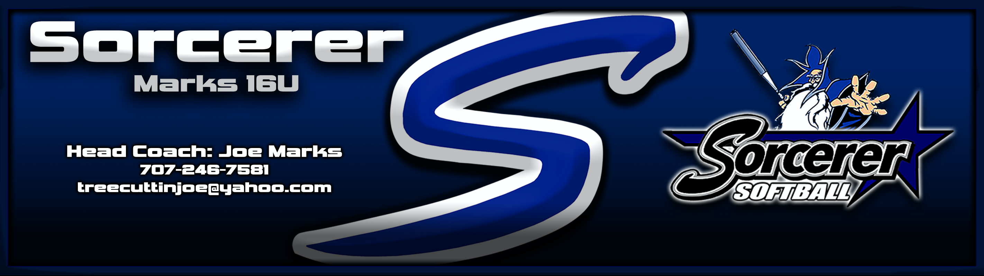

Player Name  Grad Year:  Position:  Secondary position(s):  Bats/Throws:  Height/Weight:  Home Town:  Player Email:  Player Phone:  Skill Video Link:  Parents:  Phone :  Email:  Academics  School:  Current Grade:  Current GPA:  College Major interest:  Accomplishment/Recognition | Sorcerer Marks 16U  Head Coach: Joe Marks  707-246-7581  treecuttinjoe@yahoo.com  Sorcerer website: www.sorcerersoftball.org  Event Schedule  See more info on our Team webpage:  Scan Here  http://www.sorcerersoftball.org/sorcerer-marks-16u/
Personal Statement:

#Jersey Player Name – Grad Year – Sorcerer Marks 16U

